
PRODUCT SPECIFICATION
Product Name： LED panel light
Product model：NS-WP01-5-PDQR-40K/ NS-WP01-5-PDQR-80K/ NS-WP01-7-PDQR-40K/ NS-WP01-7-PDQR-80K/ NS-WP01-15-PDQR-40K/NS-WP01-15-PDQR-80K/ NS-WP01-20-PDQR-40K/ NS-WP01-20-PDQR-80K
DESCRIPTION ： LED panel light (SMD2835)


● Features
- Using plastic integrated structure, good appearance, high class looking.
- Built-in constant current driver, high efficiency, stability.
- Using the imported SMD as light source, high light efficiency, long lifespan.
- Quick response time, the LED response time is nanosecond.
- Environmental protection, no heavy metals and harmful gas .
- Energy-saving, can save energy more 80% than traditional lights.
- . No flicker, start quickly, soft light, protect your eyes.
- . Easy to install and use.

- Technical Parameter

Model | 5W | 7W | 15W | 20W
LED model | 2835 | 2835 | 2835 | 2835
LED Qty | 13 PCS | 25 PCS | 48 PCS | 54 PCS
Voltage | AC110-240 V | AC110-240 V | AC110-240 V | AC110-240 V

Working Frequency | 50/60HZ
Power Efficiency | ≥ 90% | ≥ 90% | ≥ 90% | ≥ 90%
Luminous Flux | 380LM | 585LM | 1550LM | 1900LM
Luminous  efficiency | 84LM/W ±10% | 93LM/W ±10% | 105LM/W ±10% | 105LM/W ±10%
Power Factor | ≥ 0.5
Colour  Temperature | NW: 3710-4260K WH: 7490-8510K
CRI | Ra ≥ 80
Bean Angle | 120º
Working  Temperature | -20 to + 5 0 ºC
Service life | 30,000hr life 3yr warranty

- Relative Spectral Energy Distribution

NS-WP01-5-PDQR-40K

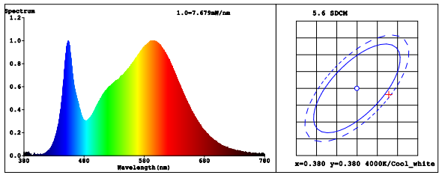

NS-WP01-20-PDQR-40K
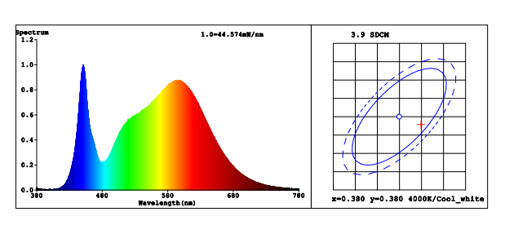

- Optical characteristic curve
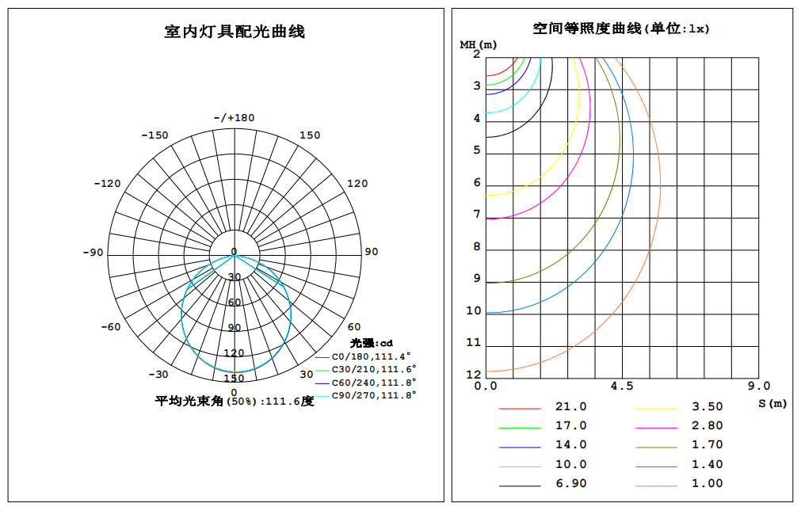
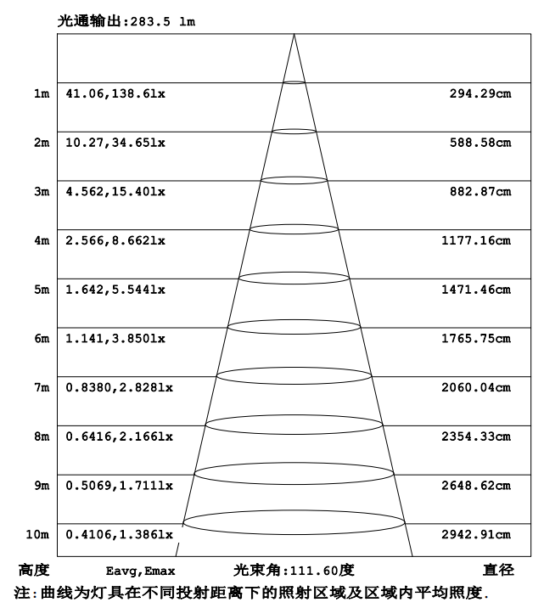
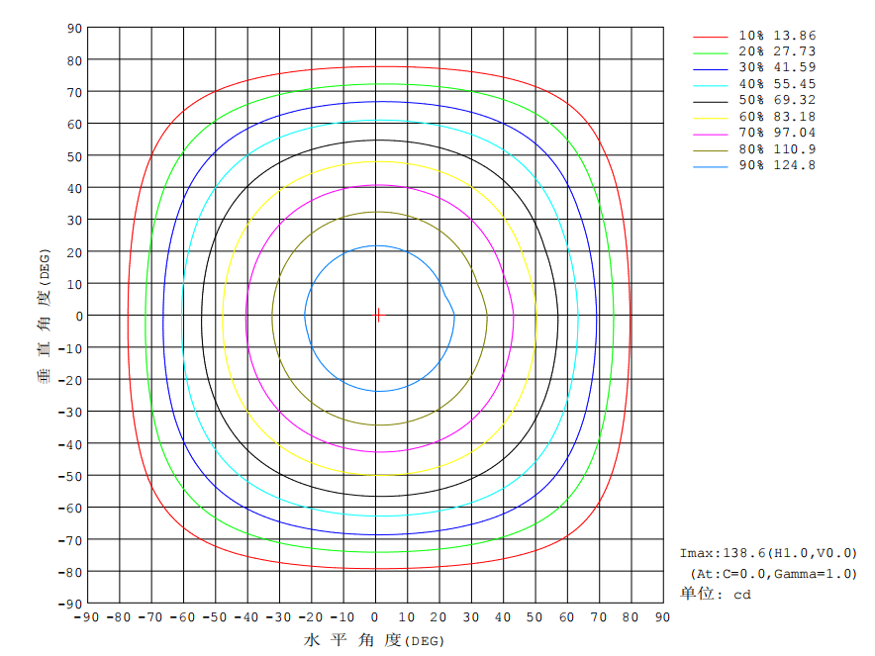
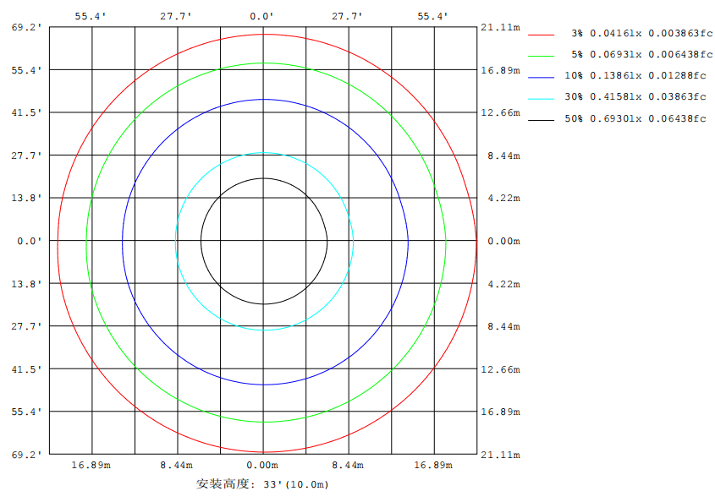

- Dimensions
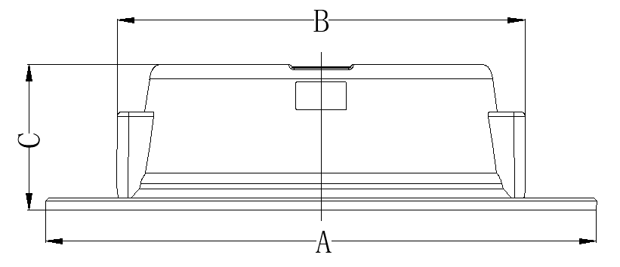
Model Diameter (mm) A(mm) B(mm) C(mm)
5W | / | 73 ± 1 | 73 ± 1 | 26 ± 1
7W | / | 118± 1 | 91 ± 1 | 26± 1
15W | / | 145± 1 | 115 ± 1 | 26± 1
20W | / | 178± 1 | 145± 1 | 26± 1

- Instruction of wiring
1.Diagram of power supply：
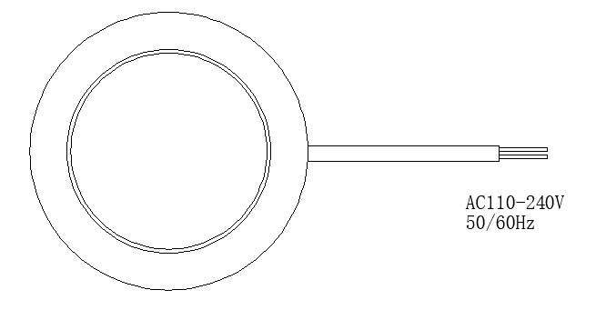

● Installation Instructions
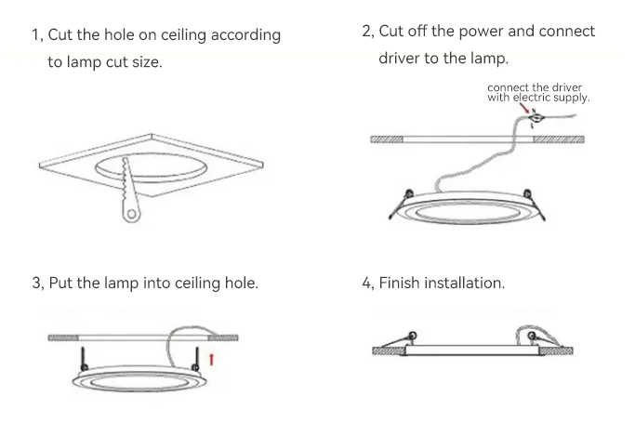

- Cut the hole on ceiling according to lamp cut size;
- Cut off the power and connect driver to the lamp;
- Put the lamp into ceiling hole;
- Finish installation;

- Product Package

NS-WP01-5-PDQR-40K & NS-WP01-5-PDQR-80K
NS-WP01-7-PDQR-40K & NS-WP01-7-PDQR-80K
Packed in color box, 100 PCS/ Master carton
NS-WP01-15-PDQR-40K & NS-WP01-15-PDQR-80K
NS-WP01-20-PDQR-40K & NS-WP01-20-PDQR-80K
Packed in color box, 40 PCS/Master carton
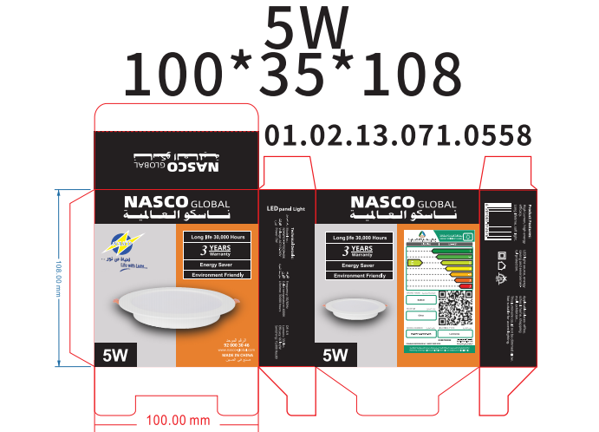
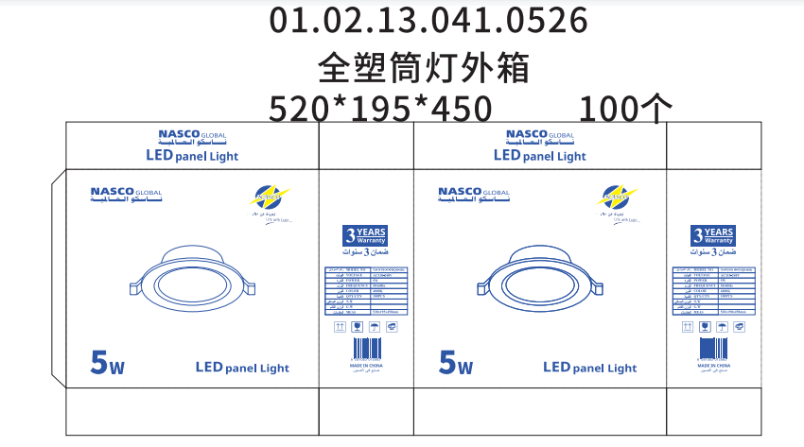

- Packing size ：
Model | L (mm) | W (mm) | H (mm)
NS-WP01-5-PDQR-40K | 520 | 195 | 450
NS-WP01-5-PDQR-80K | 520 | 195 | 450
NS-WP01-7-PDQR-40K | 620 | 195 | 510
NS-WP01-7-PDQR-80K | 620 | 195 | 510
NS-WP01-15-PDQR-40K | 375 | 345 | 400
NS-WP01-15-PDQR-80K | 375 | 345 | 400
NS-WP01-20-PDQR-40K | 460 | 345 | 480
NS-WP01-20-PDQR-80K | 460 | 345 | 480

●Attentions
1.Make sure the power is off before maintenance.
2.Clean the glass of diffuser of lamp regularly to maintain good light transmittance.
3.Clean the dust of the shell to maintain good heat dissipation performance.
4.Be careful not to use water or corrosive solution for cleaning, it is better to use a dry cloth.

●Warranty and After-sales Service
The period of guarantee is 3 years. Quality assurance is based on the correct storage, installation, use and maintenance of products. Due to improper installation
and improper use of the product, the product is damaged beyond the scope of this warranty. During the warranty period, We will choose to repair, replace (spare parts)
with new products. Labor charges or material costs will be appropriately collected over the warranty period.

● Products Application Cases
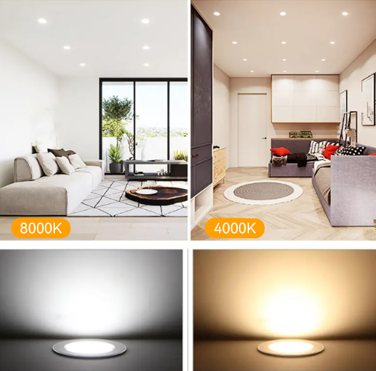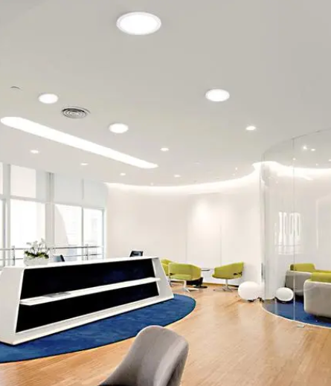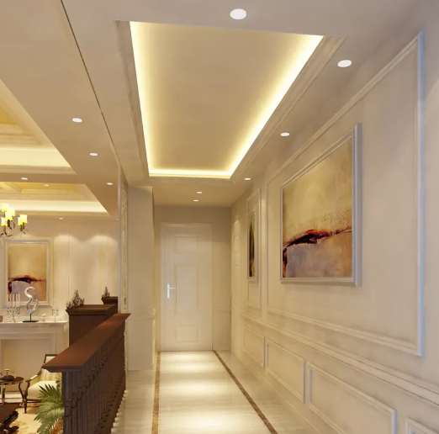

The date listed in this file is for reference only, and the specific date should be subject to the specific products, if any change, sorry for no notice .

